PROJECT VARDHUSA

A COGNITIVE BANK ASSISTANCE SYSTEM

Our objective is to provide a solution for semi-illiterate and financially illiterate persons to make transactions faster, easier and safer way, hyper personalization of banking sector expected by customers and intelligence that gives better customer experience

* Emphathising on the issue: Many people in remote areas neither have adequate knowledge on doing transactions nor even filling the form. As per past records, 56 crore (approx.) people are semi-literate and overall literacy comes down to 64.2%(approx.), the male literacy rate is 75.5%(approx.) and that of females is 52.9%(approx.) as the gap differs much between 2 different sexes and even much more in rural. Our solution will provide the better solution for semi-illiterate and financially illiterate people to make their transactions in a easier way.
* Problem Statement:
* To help people with difficult abilities in making their transactions simpler.
* To provide better customer experience to existing customers and new customers as well.
* To reduce the effort and time put in process of transactions in banks.
* To make the process more secure by multiple authentication
* Ideation:
* NLP (Natural Language Processing) is used to detect human language at the time of transaction which he has given at the time of creating his bank account, as it reduces the time instead of filling the form.
* Even it is very easy for the customer in doing the transaction as the machine speaks the language which he spoke at the time of creating bank account.
* Speech Recognition is used to match the frequency, style and pitch which he spoke at the time of transaction to the things which he has given at the time of registering with the bank.
* So, I can say speech recognition is used for voice authentication making customer feasible in making the transaction.
* CV (Computer Vision) is used for image processing where the system recognizes the face with the face which you have given at the time opening the bank account.
* There is threshold value (say 75%), where the machine doesn’t match with the threshold value, the transaction may get cancelled. So, your image should match at least 75% with image which you have given at the time of registering with the bank.

Customer Journey: This customer journey helps us to understand, how customer registering with the bank, what are the credentials he is mentioning at the time of registering & what are the technologies we are using for making customer to do transactions in a simpler way.

Old Customer

Workflow:

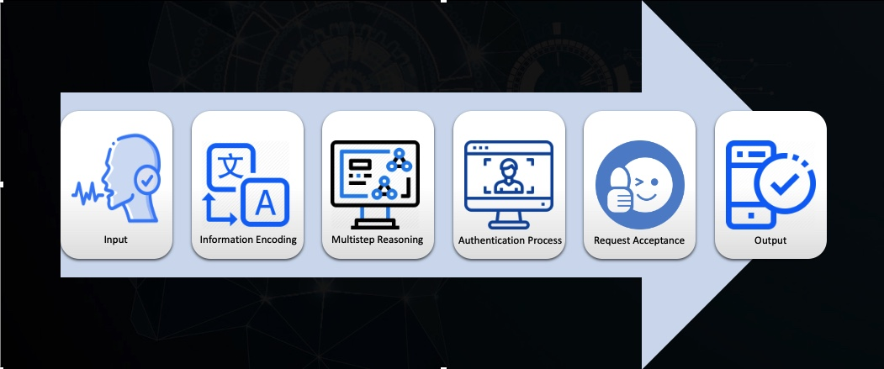

* Input: The person who wants to make the transactions speaks out what exactly he wants to and voice is taken as input
* Information encoding: The audio is being converted into text and the information in the language spoken by the person is translated into language understood by computer to initiate the transaction
* Multi-step Reasoning: In this step the AI system tries to understand the language and requirements by the input user, proceeds to authentication
* Authentication Process: The authentication is done using face recognition, speech recognition and biometrics out of which minimum of two needs to be accepted by the AI system
* Request acceptance: The request is accepted if the authentication is successful and expected output is given.
* Software tools and APIs used:
* Swift for app development
* Azure face API
* Speech recognition API
* Speech to text and Translate